- Purpose

This report provides documented evidence that alternate USP impurity limit test methods, using the Prodigy High Dispersion Simultaneous ICP Spectrometer with axial and halogen options, were validated as described in Giles method L13-PR-100-050, USP ICP Method Validation Protocol and all acceptance criteria were met as per USP 36 General Chapter <1225>. This also qualifies as a Performance Qualification for the ICP-OES.

- Scope

This validation was performed according to the procedure outlined in Giles method L13-PR-100-050, USP ICP Method Validation Protocol. It covers Giles methods L13-PR-100-057, USP ICP-OES Analysis, and L13-PR-100-058, USP ICP-OES Sample Preparation, which comprise the total USP ICP method. The total USP ICP method represents alternate USP impurity limit tests for iron (USP 36 General Chapter <241>), selenium (USP 36 General Chapter <291>), and chloride (USP 36 General Chapter <221>). It also includes the elemental impurities method (USP 36 General Chapter <233>) as an alternative to the standard heavy metals procedure (USP 36 General Chapter <231>), which requires a simple verification of suitability.

- Responsibility

QA Lab personnel are responsible for validation and revalidation of ICP methods.

- Results

Each alternate test for iron, selenium, and chloride was validated according to Giles method L13-PR-100-050, USP ICP Method Validation Protocol by testing five sets of three samples with concentrations ranging from a quarter of the USP limit to twice the USP limit. The elemental impurities test (USP 36 General Chapter <233>) was verified for suitability by testing three samples at the USP limit (USP 36 General Chapter <232>). Quality control checks of twice the USP limit passed (±20%) for the elemental impurities tests as specified in the monograph. In the results, “recovered concentration” is the “measured concentration” minus the “average unspiked concentration”.
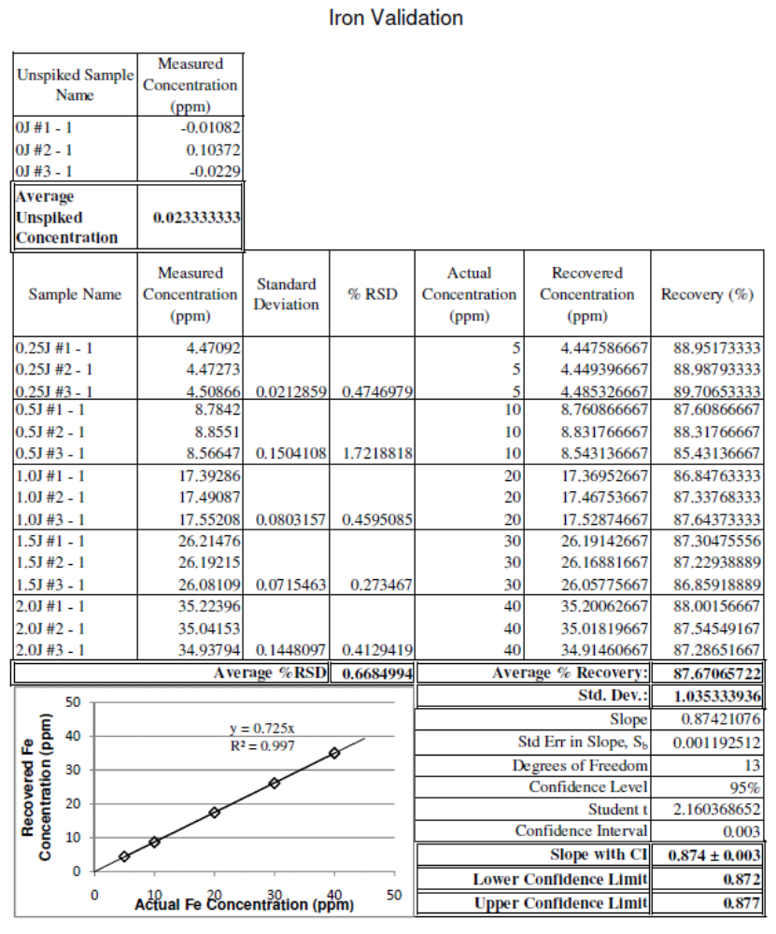
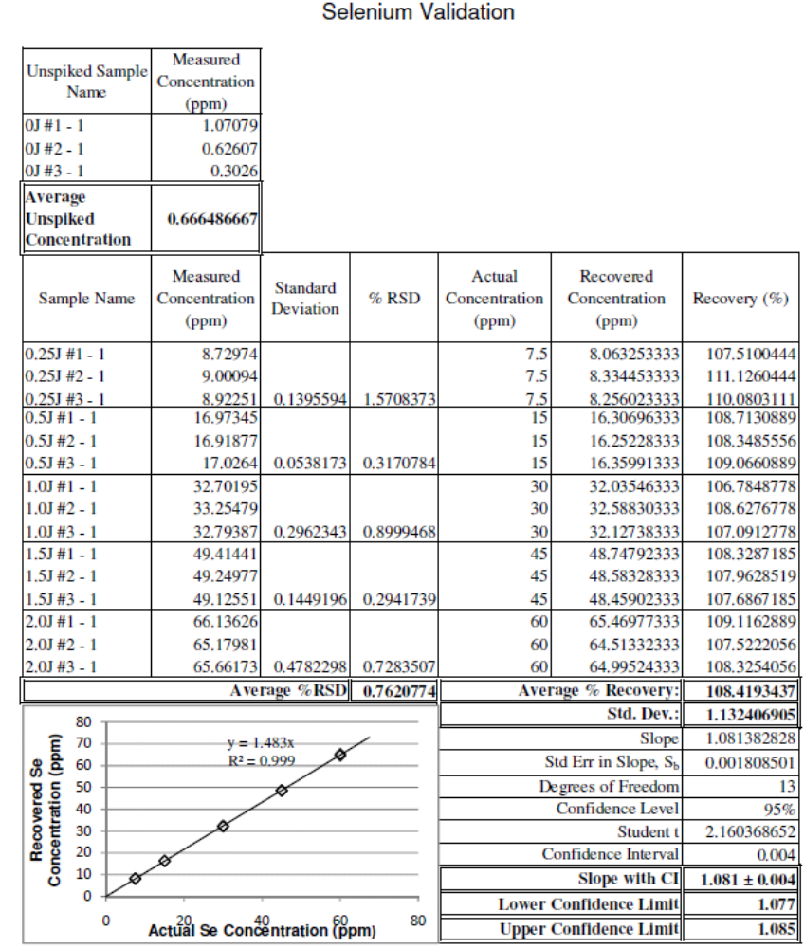
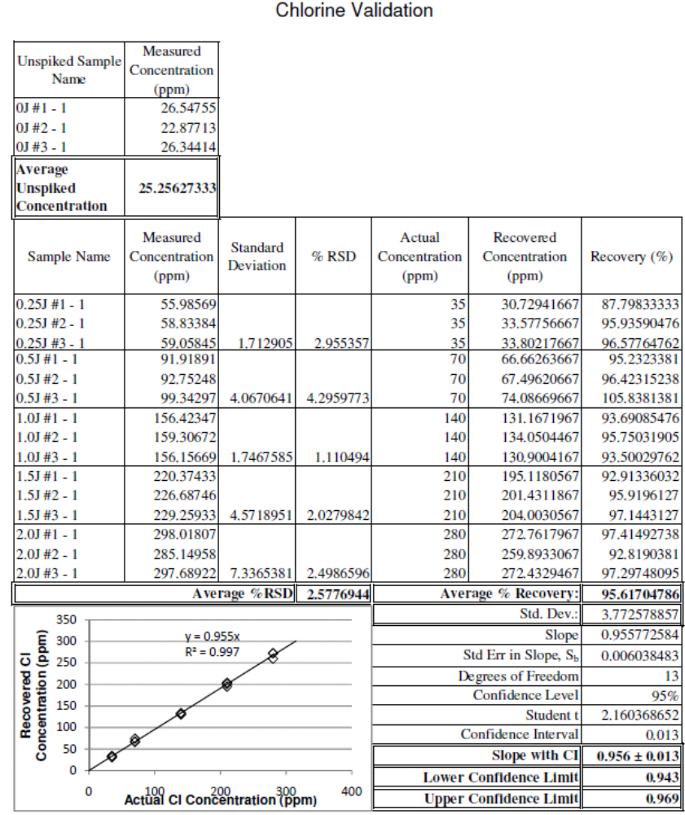

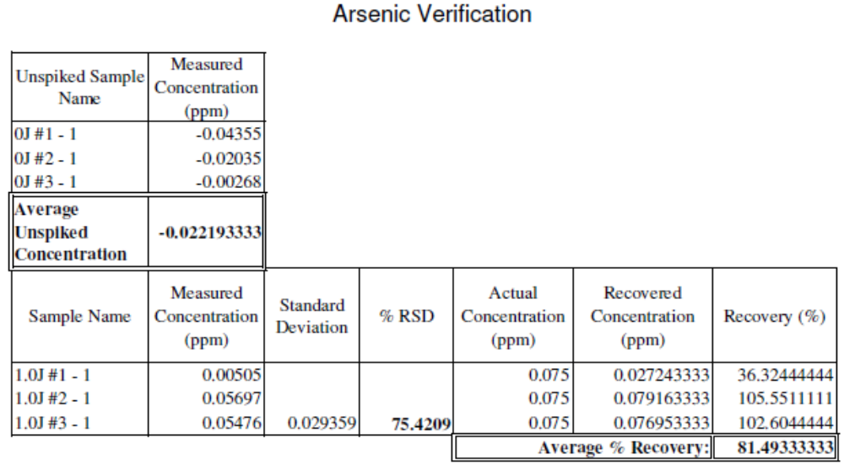

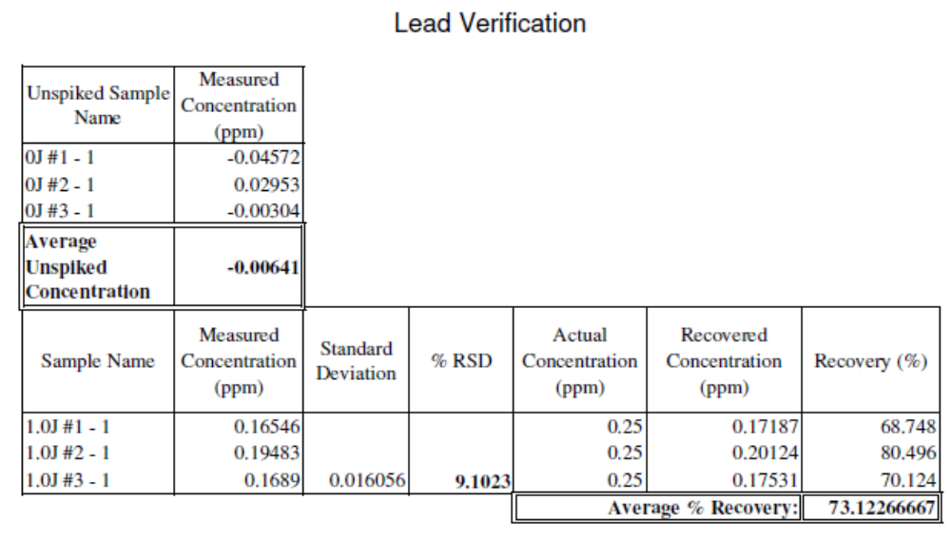
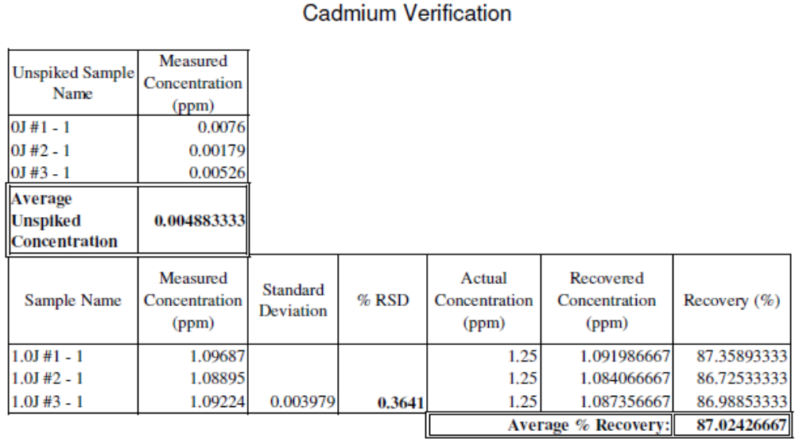

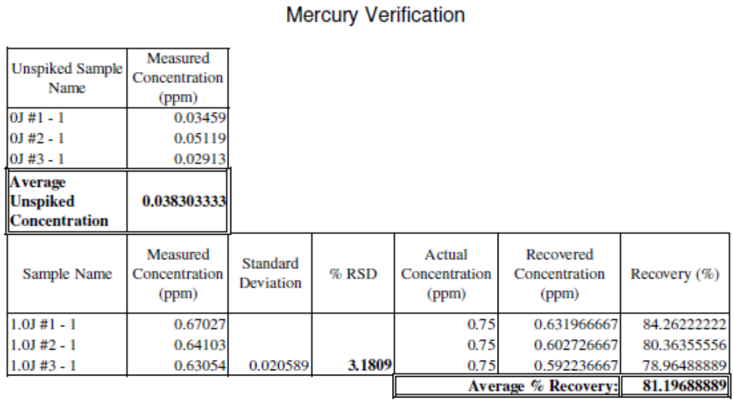

- Conclusion

IRON – SELENIUM – CHLORINE

Each validation criterion for iron, selenium, and chlorine was met, as follows:

Accuracy–The 95% confidence limits of the slope of the recovered concentration vs. actual concentration equation for each element are within ±20% of 1.0 (in other words: the confidence interval for the slope is contained within a 20% interval around 1.0 for each element). This shows acceptable accuracy for each element.

Precision–The average % RSD for each element is less than 5%. This shows acceptable precision for each element.

Specificity–For each element, the percent recoveries for all spiked samples are between 80% and 120%, and the average % RSD is less than 5%. Because all USP impurities are present in the spiked samples, this demonstrates that each element is determined with appropriate accuracy and precision; showing acceptable specificity.

Detection Limit–Determination of actual detection limits is not necessary. Rather, the detection limit for each element is evaluated to be sufficiently low if the requirements for accuracy are met, and the percent recoveries for samples spiked with 0.25 times the impurity limit are between 80% and 120%. These criteria have been met for each element, showing that the detection limit for each is below 0.25 times the impurity limit.

Linearity–For each element, the coefficient of determination (R²) for the recovered concentration vs. actual concentration equation is greater than 0.950. This shows acceptable linearity for each element.

Range–For each element, the range has be established to be the interval between 0.25 times the impurity limit and 2.0 times the impurity limit (including these levels), because these samples tested within this range show a suitable level of accuracy, precision, and linearity, as determined above.

Because of the nature of ICP-OES, the test for chloride is actually a test for total chlorine, of which chloride is a part. This test is a valid limit test for chloride because if the total chlorine is below the stated limit, then it can be assumed that the chloride (which is only part of the total chlorine) is also below the limit. If a sample is tested and found to be above the limit, the standard USP limit test will be employed to determine if this is actually due to chloride concentration alone.

ARSENIC – LEAD – CADMIUM – MERCURY

The elements to be determined using the elemental impurities method (USP general chapter <232>) include arsenic, lead, cadmium, and mercury. As these determinations are part of the overall method, the method needs to be verified to be suitable for these tests. The results for cadmium and mercury show an average recovery at each impurity limit between 80% and 120%, each with a % RSD less than 5%. Therefore, the tests for cadmium and mercury have been verified as suitable. The average recovery for lead is a little low, but still within a 30% range. The % RSD is also a little high, but still less than 10%. This is due to matrix effects, but is still acceptable if quality control checks pass as stipulated in USP 36 General Chapter <233>. The lead test has, therefore, been verified. The average recovery for arsenic is between 80% and 120%, but the % RSD is very high (75.42%). This is due to noise as the arsenic signal is weak, and the concentrations used in this verification are low (near the instrument detection limit). This is not sufficient precision to verify this test for the elemental impurities requirements of USP 36 general chapter <232> (0.075 ppm As). However, USP 36 general chapters <232> and <233> will not be implemented until May 1, 2014, so the current requirement is the heavy metals limit as specified in USP 36 general chapter <231>. This chapter specifies a heavy metals limit of 0.001% (10 ppm). This is a limit of 10 ppm for the total of arsenic, lead, cadmium, and mercury. If an out of specification limit is set at 1 ppm for each heavy metal, then even the arsenic test provides good enough precision to be verified for this determination.

- Recommendations

It is recommended that a hydride generator be purchased by the end of the fourth quarter of 2013. This will provide better detection, and therefore precision in the determination of arsenic and lead using the ICP-OES. This will need to be done in order to meet USP general chapter <232> specifications for elemental impurities by the implementation date of May 1, 2014.

- Reference Documents

USP ICP Method Validation Protocol (L13-PR-100-050)
USP ICP-OES Analysis (L13-PR-100-057)
USP ICP-OES Sample Preparation (L13-PR-100-058)

- Approvals

Signing below indicates agreement that the USP ICP method comprised of Giles methods L13-PR-100-057, USP ICP-OES Analysis, and L13-PR-100-058, USP ICP-OES Sample Preparation, as well as the Performance Qualification of the ICP-OES have been validated, and all acceptance criteria met, according to the procedure outlined in Giles method L13-PR-100-050, USP ICP Method Validation Protocol and USP General Chapter <1225>.

Project Team Member | Functional Area | Signature | Date
Stephen Ballew | Quality/R&D
Deborah Durbin | Quality
Patrick Owen | Engineering
Matt Haynes | Operations

